ENGLISH LETTERS









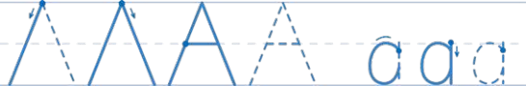

**Activity Book**



**Letters A & B**

b



**1**

|  |  |  |  |  |  |  |  |  |  |  |  |  |  |  |
| --- | --- | --- | --- | --- | --- | --- | --- | --- | --- | --- | --- | --- | --- | --- |
| a      acorn apple  B   |  |  |  |  |  | | --- | --- | --- | --- | --- | |  |  |  |  |  | |  |  |  |  |  |  |  |  |  |  | | --- | --- | --- | --- | |  |  |  |  |     ball bird |

**Letters C & D**



**2**

|  |  |  |  |  |  |  |  |  |  |
| --- | --- | --- | --- | --- | --- | --- | --- | --- | --- |
| C   |  | | --- | |  | |  | | c | |  | |  |     car cat  D   |  |  | | --- | --- | |  |  | |  |  |   d      dog duck |

**Letters E & F**



**3**

|  |
| --- |
| E  e    elephant elf  F  f |
| fish fox |

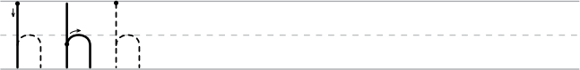

**Letters G & H**

h



**4**

|  |  |  |  |  |
| --- | --- | --- | --- | --- |
| G   |  | | --- | |  | |  | | g |     guitar grapes  H | |
|  |  |
| heart house | |

**Letters I & J**



**5**

|  |  |  |
| --- | --- | --- |
| i   |  |  | | --- | --- | | J  j | igloo iguana |   jar  juice  jar juice |

**Letters K & L**

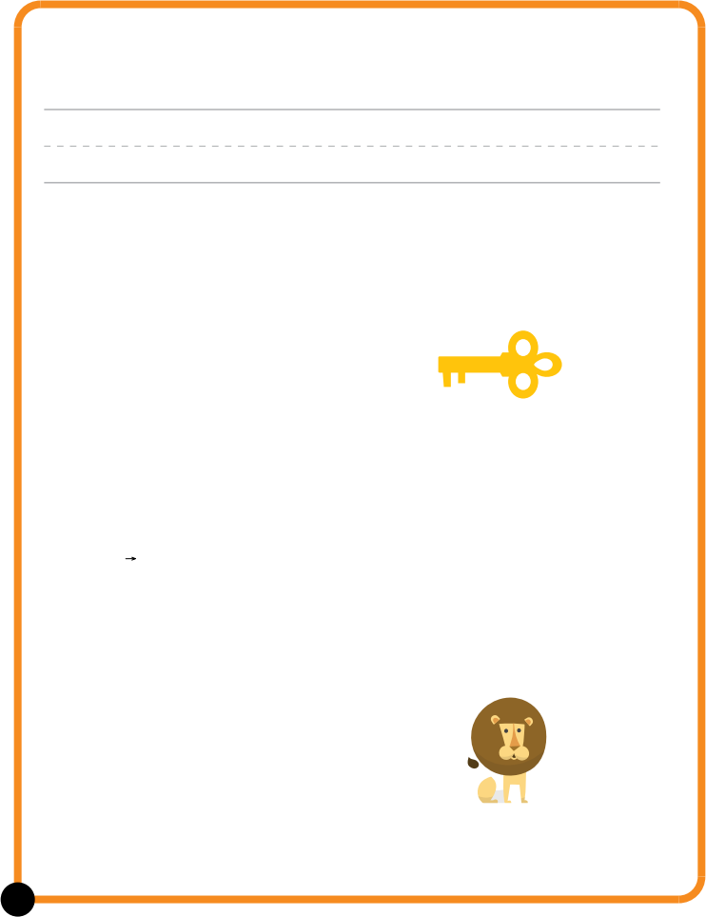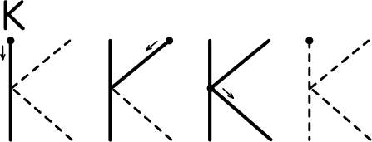

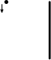k







kite key

L



l





leaf lion

**6**

**Letters M & N**



**7**

|  |
| --- |
| m      moon monkey    n      nectarine nest |

**Letters O & P**



**8**

|  |  |  |  |  |  |  |  |  |  |  |  |
| --- | --- | --- | --- | --- | --- | --- | --- | --- | --- | --- | --- |
| O   |  | | --- | |  | |  | | o |     orange octopus  P   |  |  |  |  | | --- | --- | --- | --- | |  |  |  |  | |  |  |  |  |   p      panda penguin |

**Letters Q & R**



**9**

|  |  |  |  |  |  |  |  |  |  |  |  |  |  |  |  |  |  |  |  |
| --- | --- | --- | --- | --- | --- | --- | --- | --- | --- | --- | --- | --- | --- | --- | --- | --- | --- | --- | --- |
| Q   |  | | --- | |  | |  | | q |  |  |  | | --- | --- | |  |  |   quail  queen  R   |  |  |  |  |  | | --- | --- | --- | --- | --- | |  |  |  |  |  | |  |  |  |  |  |   r   |  |  |  |  | | --- | --- | --- | --- | |  |  |  |  |     raccoon rainbow |

**Letters S & T**

t

|  |  |  |  |
| --- | --- | --- | --- |
|  |  |  |  |
|  |
|  |  |  |  |



**10**

|  |  |  |  |  |  |  |  |  |  |  |  |  |  |
| --- | --- | --- | --- | --- | --- | --- | --- | --- | --- | --- | --- | --- | --- |
| S   |  | | --- | |  | |  | | s | |  | |  |     starfish sun  T   |  |  |  |  | | --- | --- | --- | --- | |  |  |  |  | |  |  |  |  |     turtle  train |

**Letters U, V & W**



umbrella



watermelon



**11**

|  |  |  |  |  |  |  |  |  |  |
| --- | --- | --- | --- | --- | --- | --- | --- | --- | --- |
| u  U   |  |  | | --- | --- | |  |  | |  | | |  | |     V  volcano  v    W   |  | | --- | |  | |  | | w | |

**Letters X, Y & Z**



yo-yo



**12**

|  |  |  |  |  |  |
| --- | --- | --- | --- | --- | --- |
| x-ray  x   |  | | --- | |  | |  | |  | |  | | y |     Z  zebra    z |
| Free Printable Number Tracing Worksheets (1) |





